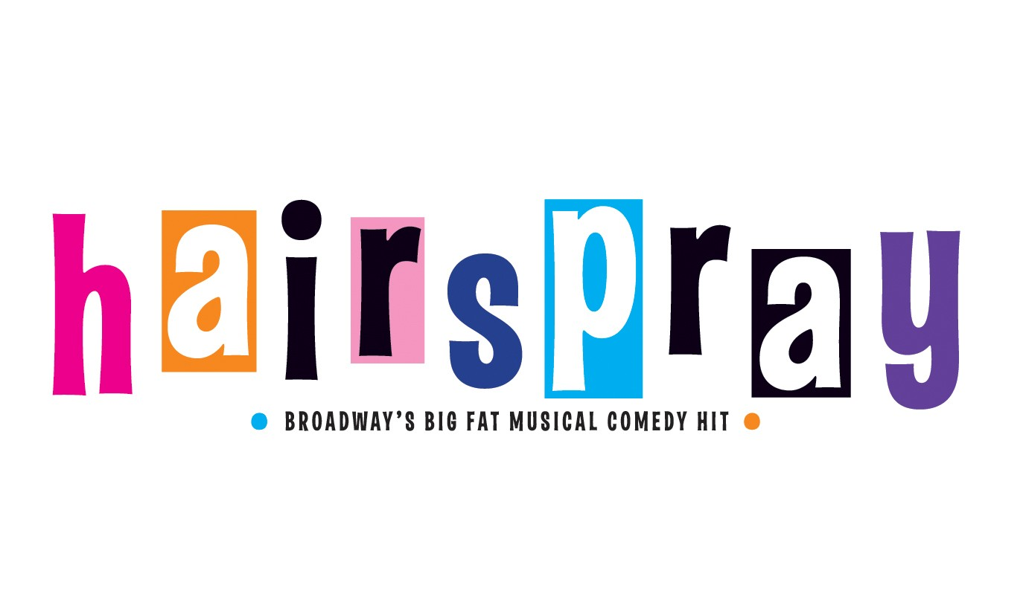

- HEATHER DIGNAM
- CAELINN RICHARDSON
- REBECCA TROY
- ELLIE MARRON
- KATE HYLAND
- CIARA TAHENY*
- AMY MC GRATH
- KEELIN GALVIN
- LAUREN HARRELL
- MOLLY NOLAN
- URARA KODAMA
- CAROLINE KANE*
- PETER DILLON
- LAURA FARRELL
- AISLING PHELAN*
- LAUREN FARRELL
- SARAH JENNINGS
- NIAMH HUGHES
- ELLEN HEFFERNAN
- JENNY KELLY*
- CAOIMHE HAYDEN
- AVA FLANAGAN*
- ALI KAVANAGH*
- MILLIE AHERN O’DONNELL
- DERYN MOONEY*
- JOSHUA BARRY CULLEN
- RUAIRI FINAN*
- CHLOE CASSIDY

- GRACE FARRELL
- JILL BROWNE
- SARAH HENRY
- SINEAD MC CARTHY
- DAVY CULLITON
- CONOR JOHNSON
- MICHELLE WINTERS
- SARAH TAHENY
- JADE SILKE FETHERSTON
- EMMA-JANE GRANT
- DANIELLA TRAYNOR
- ELEANOR YOUNGE
- HOLLY MURPHY
- AOIFE RUTLEDGE
- AISLING BYRNE
- EMER O’CONNOR
- ELLEN BYRNE
- OLIVIA CASSIDY
- BRONAGH NUGENT
- ANNA TIGHE
- KATE HENSEY
- AOIFE BUCKLEY
- CAOIMHE MC DONNELL
- MADDIE GILLESPIE
- MEADHBH BRASSIL
- MEGAN FLANAGAN
- MAIREAD SHERIDAN
- KIRSTEN MC GRATH
- REBECCA ROWLAND
- ELIZABETH MC BRIDE
- REBECCA GLENNY
- AINE FLEMING
- LAUREN MULDOWNEY
- LAURA FITZGERALD
- ELLEN JORDAN
- SARAH BEEHAN
- JOYCE DELANEY
- AUTUMN CAREY
- BETHANY CARR
- SABRINA KEANE
- ELLEN MAGUIRE
- ROISIN KEARNS
- MORGAN HURLEY O’DWYER
- SALLY-ANN HENNESSY
- DIDIER CORDONNIER
- FIONN O’SULLIVAN
- HOLLY HENSEY
- RIONA LITTLE
- ISABELLE O’TOOLE
- KOTRYNA STEPANOVA*
- SAM BURKE*
- ABIGAIL MURPHY*
- ROSIN KING*
- HANNAH EGAN*

- MATT MC CARTHY | - HAYLEY MULCAHY
- BARRY FINAN | - GRAINNE RAFFERTY
- MARK SUTTON* | - NIALL DELAHUNT
- J.P PHELAN | - ROBYN FLANAGAN
- CONN WHELAN | - FIONA WATTERS
- JACK MAGUIRE | - ALI O’BRIEN
- CIAN O’BRIEN* | - GAVIN O’NEILL*
- MUIREANN SCULLY | - NIALL CALLANAN
- MATTHEW MARMION | - JUSTIN DEANE*
- NICOLA FLANAGAN* | - SORCHA LAVELLE WALSH*
- AOIFE HORAN* | - SARAH COLLER*
- CAOIMHE CORBETT | - CIARA PHELAN
- TORI LAHART O’REILLY | - KATHERINE MURPHY*
- MARK GALLIGAN* | - CIARA MC GRATH
- FRANCESCA MC ALLISTER | - SAOIRSE MOONEY
- KAREN FOLEY | - JESSICA DEVLIN*
- AOIFE FENNELL* | - AOIFE CLARE
- CHLOE O’REILLY* | - EDEL KELLY
- MELANIE WALSH | - REBECCA BORTON
- CHLOE MC GRATTIN BRAZZIL | - AMY FITZGERALD
- JESSIE HUI* | - TOM HIGGINS*
- HUGH O’DONNELL* | - SEAN ROONEY
- RICHARD DROMGOOLE-MAGUIRE | - RACHEL HOVENDAN-KEANE

