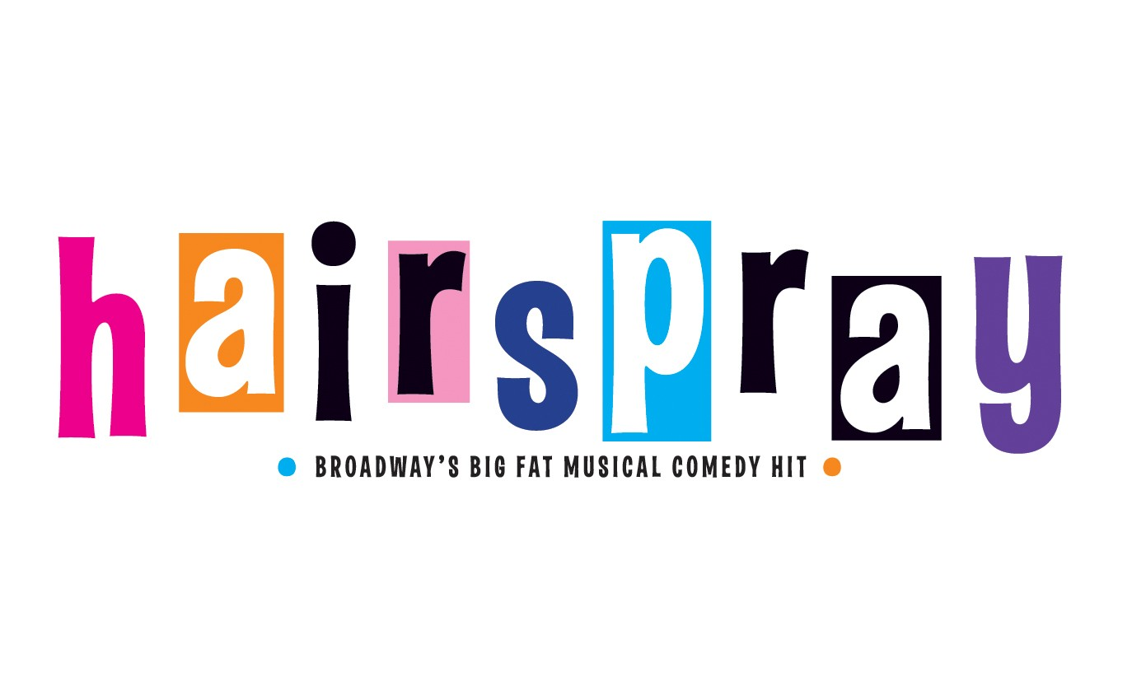
Principles;
TRACY TURNBLAD | EMMA JANE GRANT
CORNY COLLINS | MARK SUTTON
EDNA | HUGH O’DONNELL
PENNY PINGLETON | BRONAGH NUGENT
VELMA VON TUSSLE | TORI LAHART-O’REILLY
AMBER VON TUSSLE | SORCHA LAVELLE WALSH
LINK LARKIN | TOM HIGGINS
SEAWEED J. STUBBS | GAVIN O’NEILL
LITTLE INEZ | MICHELLE WINTERS
MOTORMOUTH MAYBELLE | DANIELLA TRAYNOR
WILBUR TURNBLAD | MARK GALLIGAN
PRUDY PINGLETON | SARAH COLLER
MR. PINKY | SAM BURKE
GYM TEACHER | RUAIRI FINAN
HARRIMAN SPRITZER | BARRY FINAN
MATRON | KATHERINE MURPHY
GILBERT | CIAN O’BRIEN
CINDY WATKINS | DERYN MOONEY
PRINCIPAL | NICOLA FLANAGAN
LOU ANN | AOIFE BUCKLEY
NEWSCASTER | CHLOE O’REILLY
GUARD | JONATHAN PHELAN
COUNCILETTES | HAYLEY MULCAHY  RACHEL HOVENDAN KEANE
THE DYNAMITES | AOIFE HORAN  KOTRYNA STEPANOVA  JESSICA DEVLIN

