GIRLS UNIFORM SHOES
Black Leather shoes similar to those below:

Option A – Black Leather Ballet Flats

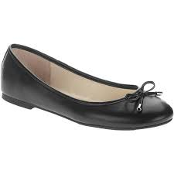

Option C – Black Susst shoes

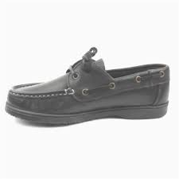

Option B – Black Flat Leather Shoes

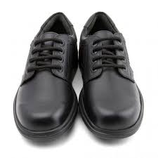

Option D – Black AV8

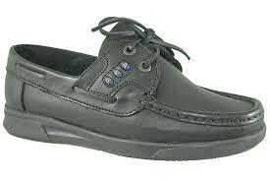

BOYS UNIFORM SHOES

Black Shoes – Black Leather shoes similar to those below:

